STEP 1:

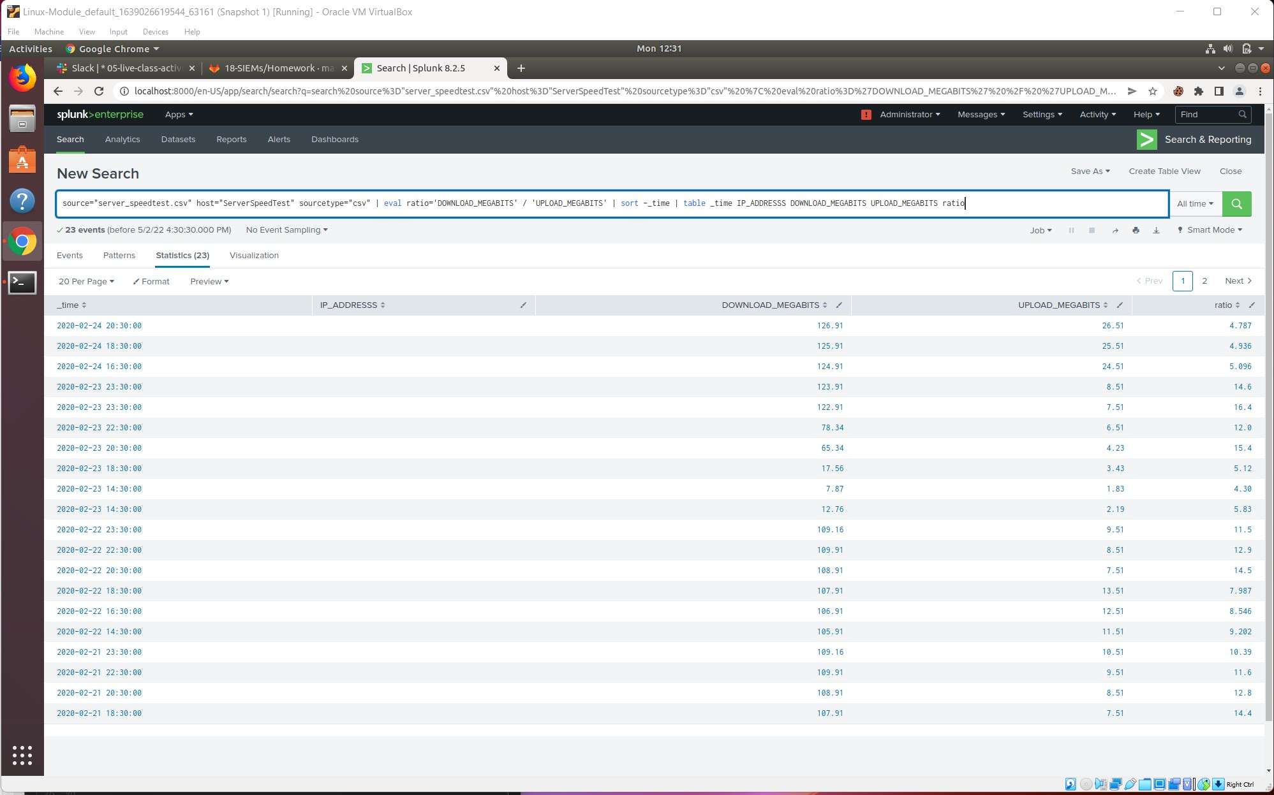

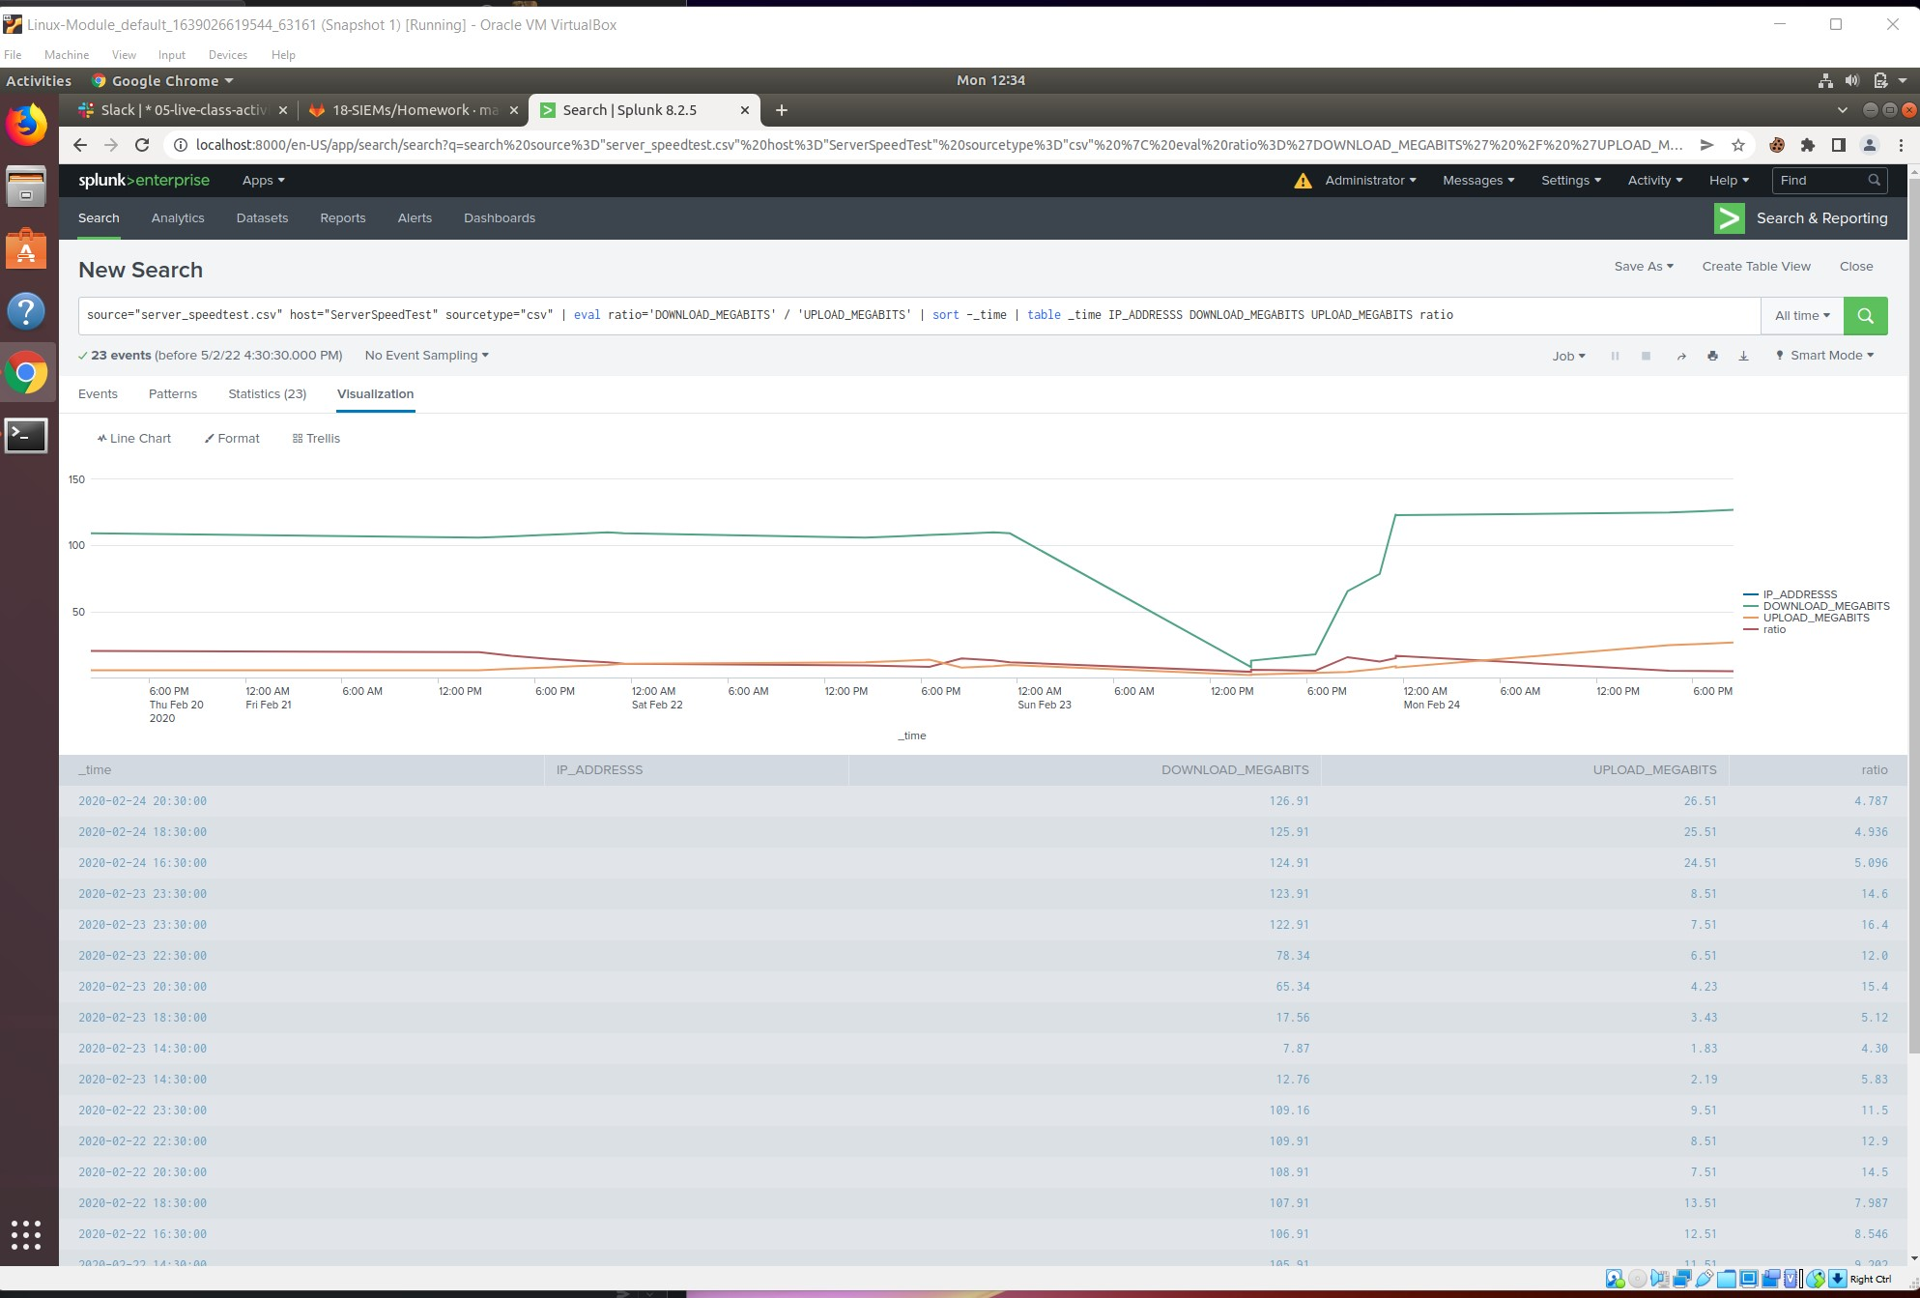

Based on the report created, what is the approximate date and time of the attack?

* The report shows that the approximate date and time of the attack was at about 2:30 PM on Sunday, February 23, 2020. Looking at the Line Chart, we can see that the DONWLOAD_MEGATBITS speed took a serious plunge at this time.

How long did it take your systems to recover?

* The system took about 11:30 PM on February 23, 2020. Looking at the Line Chart, we can see that at this time, the DOWNLOAD_MEGABITS speed returned to the normal range at about 122.91 megabits/second. This means it took about 9 hours for the systems to recover.

STEP 2:

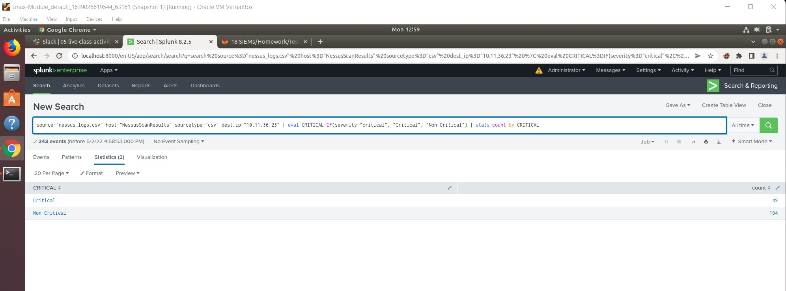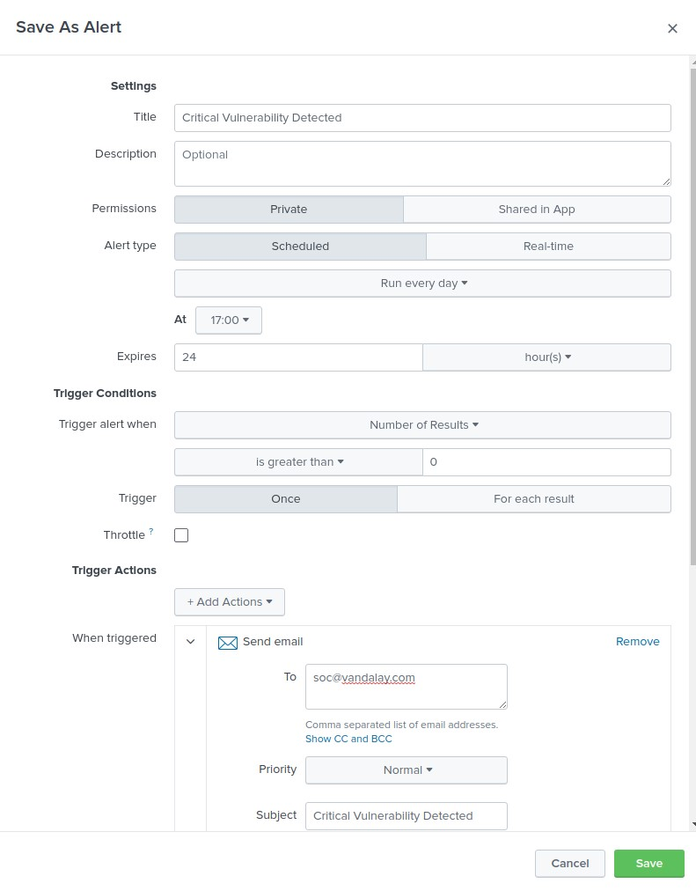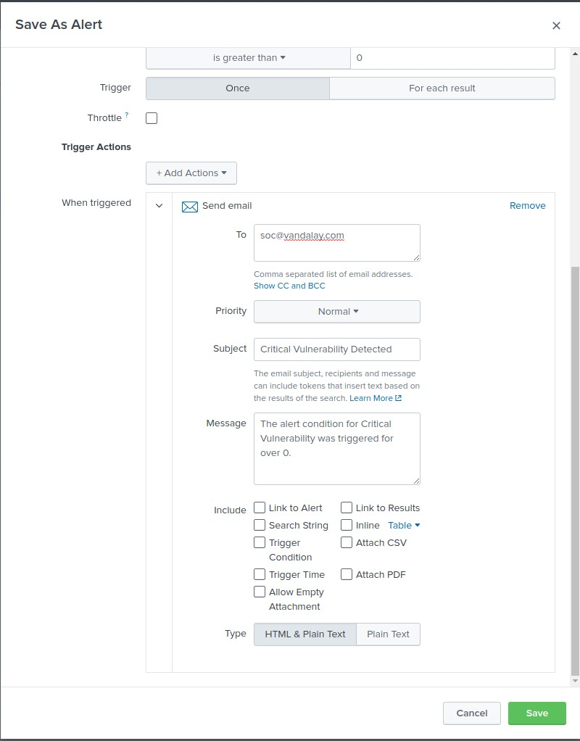

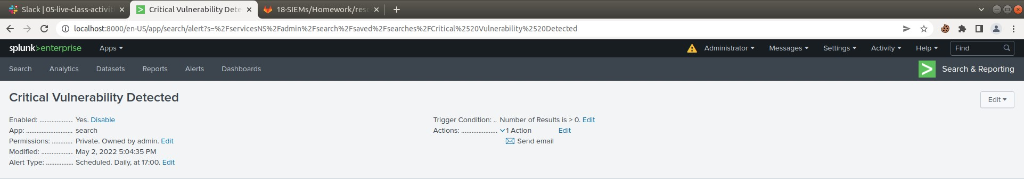

STEP 3:

